Code Review: I2301038
Reviewer: James Wood
Date: May 31st, 2023
Bugs
- The Qty field that’s reviewed for serial tracked items should be the QtyToStock, as that’s how the inventory will actually be stored and referenced in the system(I think Shawn noted this in the ticket in one of his early journals). Whatever the QtyReceived may be is irrelevant for this validation. While these two UOMs being different is likely not a common occurrence, the fact that it is a valid scenario means we do need to handle it.
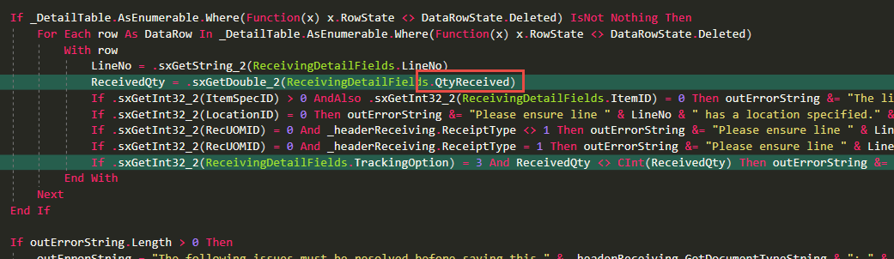
Preventative Action/Safety
Design/Architecture (Duplication, appropriate project, namespaces, maintainability)
Data Model(Naming, good design, needs index?)
Performance (Minimize DB hits, excessive loops, queries, scalable)
UI(Alignment, naming, standardization)
Error Handling(Behind events, appropriate parameter checking)
Cleanup (Dispose code, remove handlers, large data objects)
Readability (Well-named variables, methods, clear algorithm, is it understandable)
- When applicable, check to see if we have an existing Enum for a constant value.
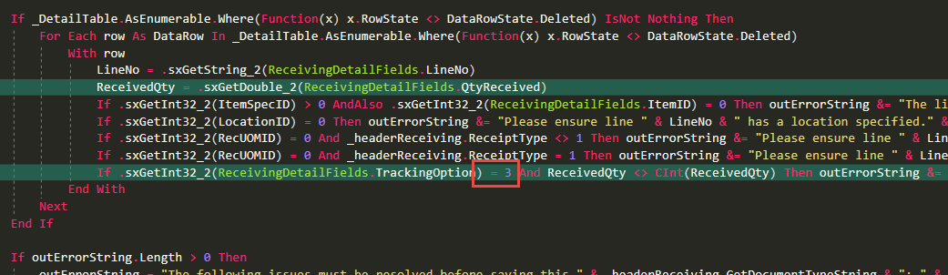
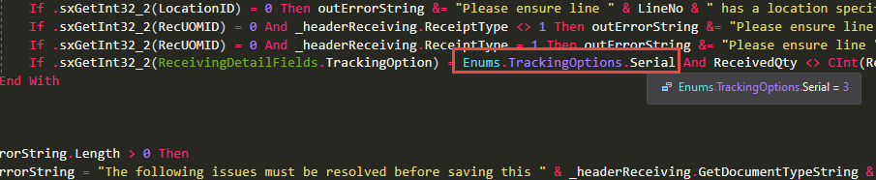
Comments (Useful, explains why rather than how)
Message Boxes (Grammar, spelling, captions, appropriate icons)
- Since we’re changing the qty value to be the Qty to Stock, the message should be changed as well.
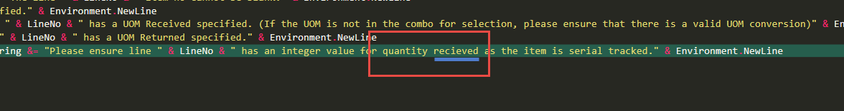
Ticket Management(Release Branch?, Testing Notes)
Extras
- Nit: .Net has the built-in ability to do short-circuited conditionals, AndAlso and OrElse(syntactic sugar), and we strive to use them everywhere, when applicable. The main benefit is to inform the system to not run the remaining checks if the previous condition succeeded or failed(depending on the operator). This has two benefits, reducing the amount of code because now we can check if an object exists and only if that’s true, then use it for another check:
If _PO Is Nothing OrElse _PO.POID = 0 Then
Without the OrElse, if _PO was actually Nothing, the second condition would throw an error. Of course, this benefit does not apply to all conditionals, including the ones you entered, so no biggy there.
The second benefit, which does apply to everything, is a very minor performance boost, but a boost nonetheless, with no downside.
Both change sections had an instance of this. AndAlso can always replace And, and OrElse can always replace Or, unless both sides need to be executed, which is a possibility, but AndAlso and OrElse are the rules, not the exception.
